**Week 2 – Responsive web design, HTML, CSS and JavaScript**

**Task 1 (Pass)**

Responsive web design is an approach to web design that makes web pages render well on a variety of devices and window screen sizes. Responsive web design utilised flexible layouts and images which is controlled using CSS media queries that allow the user to adjust their web browser to any size and orientation, in which the web page will adjust accordingly.

**Task 2 (Pass)**

The implementation of responsive web design can be accomplished through CSS, using the @media rule. The @media rule can be applied to a website in order to change different elements of the browser. Media queries can be used in order to change the height and width of the device and browser, the orientation of the device (if using mobile or tablet in landscape or portrait modes), as well as the screen resolution.

**Task 3 (Credit)**

User stories

UI/UX

<https://www.figma.com/proto/wBhwqHvMn9fk9RpDh78PpL/Untitled?node-id=2%3A2&scaling=min-zoom&page-id=0%3A1&starting-point-node-id=2%3A2>

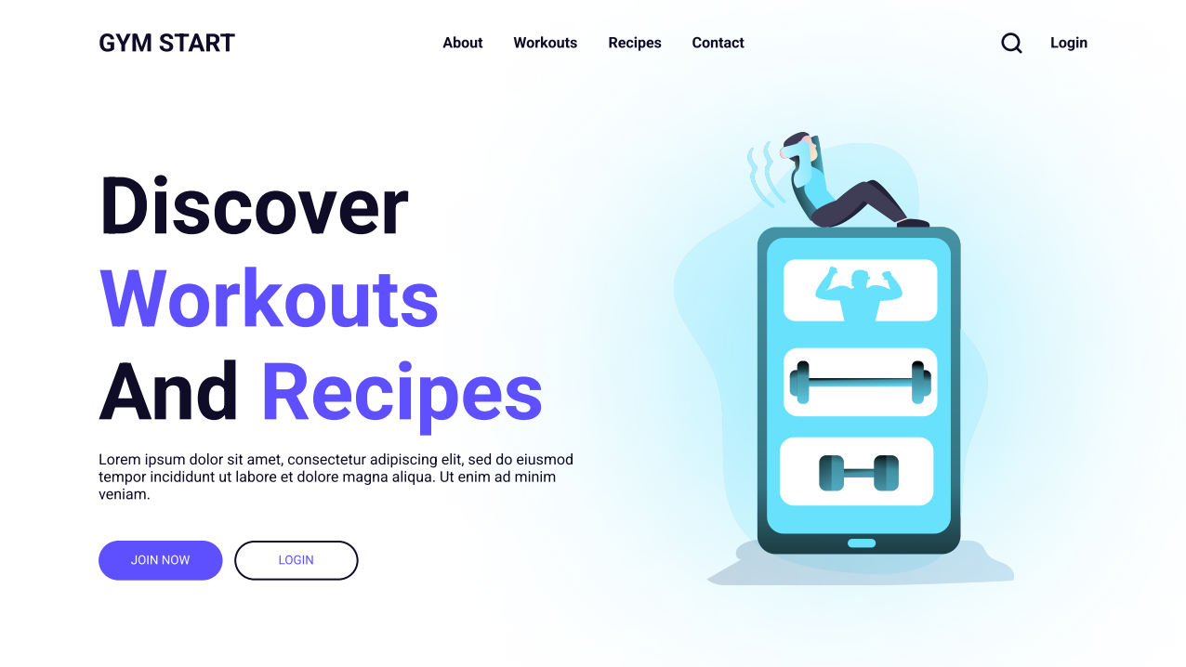

**Task 4 (Distinction)**

User stories